Sana’a
UNIVERSITY
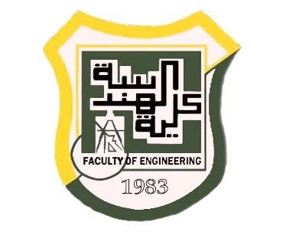
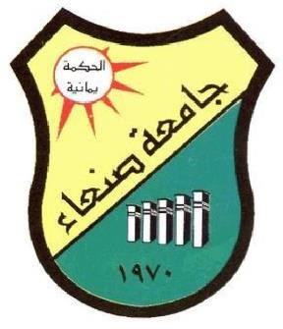

FACULTY OF ENGINEERING

Mechatronics Department

Second Year

Report
Thermal Simulation In Solid work

Supervision
Prof. Hamod Alnhary
Eng. Asim

Adopted by

Ibrahim Alkhlydy 202073007
Mechatronics (Parallel)

Table of Contents

Introduction............................................................................................................... ............. 1

Objecti........................................................................................................................................ 2

Methodology ...................................................................................................................... 3

Equipment........................................................................................................................... 4

Procedures........................................................................................................................... 5

Simulation........................................................................................................................... 6

Results.................................................................................................................................. 7
Graph………………………………………………………………………………….7

Obstacles….................................................................................................... 8

References.............................................................................................................................................................. 9

Introduction:

The experience to learn how we can make simulation for the (conduction or convection or radiation) and make all of this in the Solid work And from the Solid work I make my project. My project is from five poles put it until the holes of the bases. The poles made of (Silver, Copper, Aluminum, Brass, Nickel) and how transmission the heat in the materials

Objectives:

The objective of the project how to make simulation in solid work and how the hat transmission in the materials.

Methodology:

The methodology is a simulation of the heat transmission in the materials And the calibration of the heat

Equipment:

1) Bases
2) Five poles
a) Aluminum
b) Brass
c) Capper
d) Silver
e) Nickel

Procedures:

First: make the base
Second: make five holes at the same dimeter
Third: make five poles
Forth: put the poles until the holes

- Simulation
The full project in the solid work

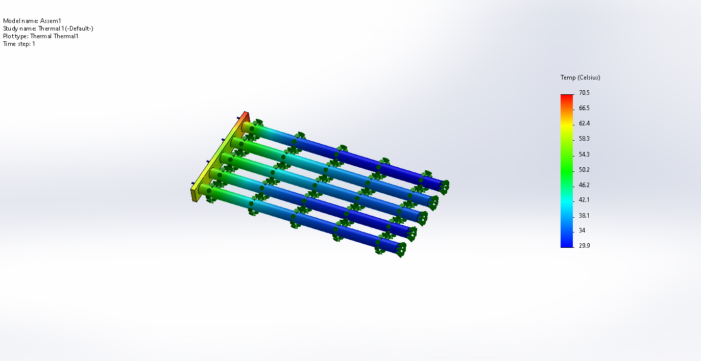

The base

The poles



- Rules

Graph
- Aluminum

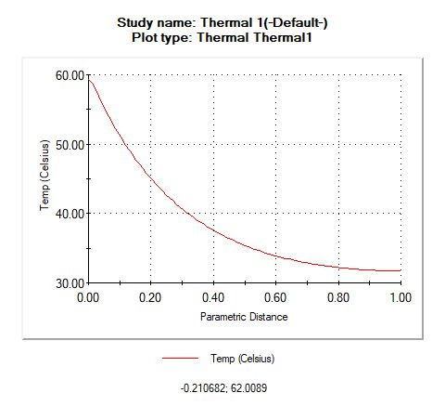
- Brass
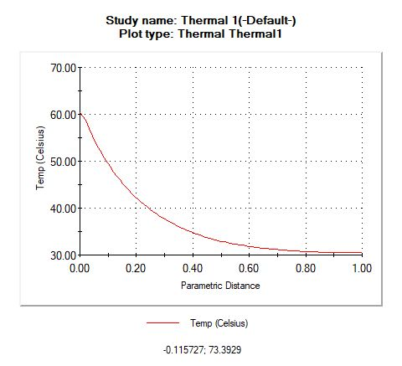
- Copper
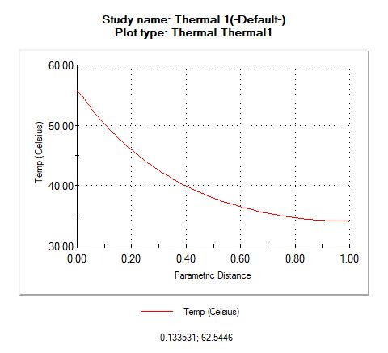
- Silver

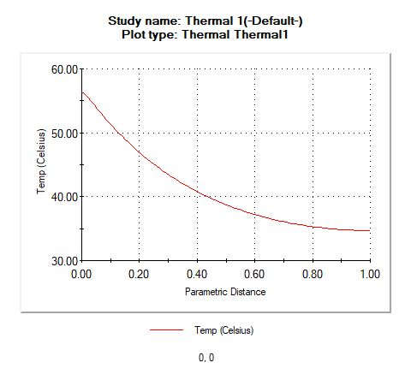

- Nickel
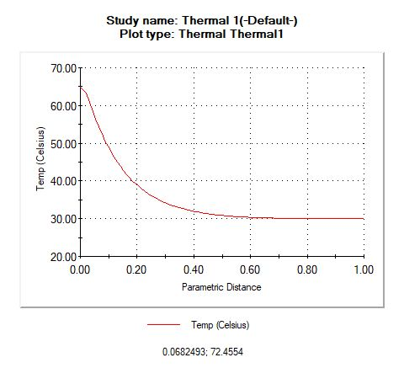

Obstacles:
1) The first obstacle is when I assembly my project it is nor running I do not know what happened
2) The second thing is I do not know how to make a thermal Simulation but in the end I get it
3) In the end. The biggest thing is how to choose the mettles
And how to simulation it in solid work

- References:
From You top and Google

